# File permissions in Linux

## Project description

This project helps us ensure that authorized personnel possess the required permissions while concurrently mitigating any potential risks associated with unauthorized access and also help us maintain the principle of least privilege.

## Check file and directory details

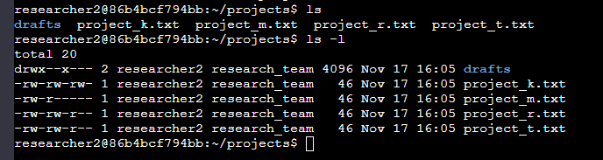

Here we have all the files that are available in the project directory and also from the second command we can see all the permissions for all the files and directories present in the current working directory.

## Describe the permissions string

In linux, a permission string of 10 characters is a representation of file or directory permissions using a combination of characters that indicate the access rights for different user groups. A typical example would be “-rwxrw-r-x”. Here, the first letter describes if it is a directory or a file, next 3 related to the user, next 3 is group and last 3 is related to others. Here r stands for read, w stands for write, x stands for execute, if not a ‘-’ is used.

## Change file permissions

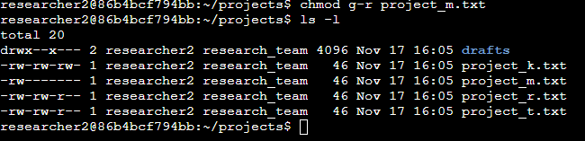

Here we can see from the command we changed the permissions by removing read permission from the group for the project_m.txt file. And can be seen from the screenshot

## Change file permissions on a hidden file

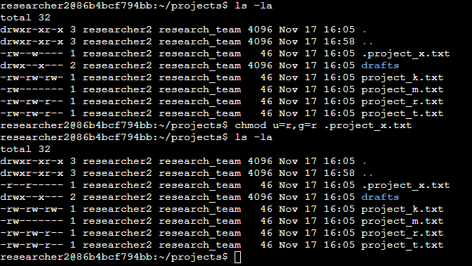

Here it is the same we can spot the difference between before and after the execution of command.

## Change directory permissions

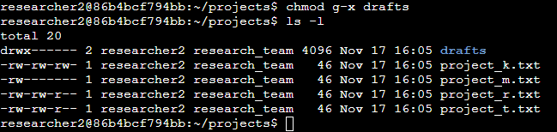

Same as we can change permissions for a file we can also do the same for directories as well. In this image we can see the same for drafts folder.

## Summary

By using the above commands and maintaining the principle of least privilege we have heightened security and operational efficiency. And also helps reduce the risks that might have due to unnecessary permissions.